**Team 4 - Software Development Plan (SDP)**

**A. Product Description**

**i. Product Description:** Application which monitors a store’s capacity real-time and has an online ordering/pickup feature.

**ii. Who is the client:**  We have two users/clients that will benefit from our program:

1. **Store Managers:** 
   1. **Who are they:** Owners of the store in charge of the total business operations and meeting local regulations.
   2. **How does this application benefit them:** This application will assist to have an automated system to allow store managers to see the use condition of their store in real time. This means how many people are entering/leaving the store, and how many are within the store at a given time. This feature is very helpful for a business to monitor trends and adjust their business model to maximize its output. Also this application is seeking to streamline the buying process so that shoppers can place orders and pickup. This exponentially reduces the congestion in the store, the time at store, but increases total sales. There is an added perk during a time of a pandemic. With COVID19 restrictions from local governments, the governments are putting the impossible task for store owners to manage the capacities in real time. This is almost impossible to do without an automated real-time monitoring system.
2. **Private Citizens:**
   1. **Who are they:** Visitors and purchasers of the store.
   2. **How does this application benefit them:** This application will allow a citizen to know the real-time capacity condition of a store. This is very helpful to maximize a users efficiency or in the case of COVID19 to help those with immuno-compromised conditions make the best plan for their health. Also this application goes even further to allow online shopping from home with the ease of pickup. This greatly reduces the time needed for the citizen to get groceries and completely eliminates the need to go in the store as pickup is outside.

**B. Team Description**

We are using Java to develop the application. Below are the skills need to develop this projects

1)Should be able gather the requirements and analyze them

2)Design the architecture of the project

3)should be able to develop the project plan i.e resources availability, deadlines of project completion etc

4)knowledge on below is must

Programming languages: java

IDE : Visual Studio

Repository: Github

5)Strong End to End testing is required

**C. Software Process Model Description -**

Our team will use an **agile** approach to software development. The reason is that key features will piggyback on top of each other. So developing the MVP first and then iterating on that will allow us to continue to improve the application most efficiently. The core features are not that complicated and using the agile approach will allow us to get a working prototype right away to test on and get user feedback to continue to improve.

**D. Project Definition**

Store manager assistant Tool is useful to order groceries ,medicines or any other items online from our home.

Recently there were lockdowns everywhere to avoid the spread of covid19, as a result of this many of us faced many issues in getting their daily needs met.

This app helps to avoid going to stores to get our daily needs. This app also helps users to check the capacity and wait time so that they can decide to visit the store or order online. This App also helps the store owners to keep an eye on the count of people visiting their stores frequently,so that they can plan the precautions that need to be taken if people visit their stores .

By using this app all our essentials will get delivered to our home just by ordering them online. Below is the flow diagram.(A larger version is also available with our Canvas submission)

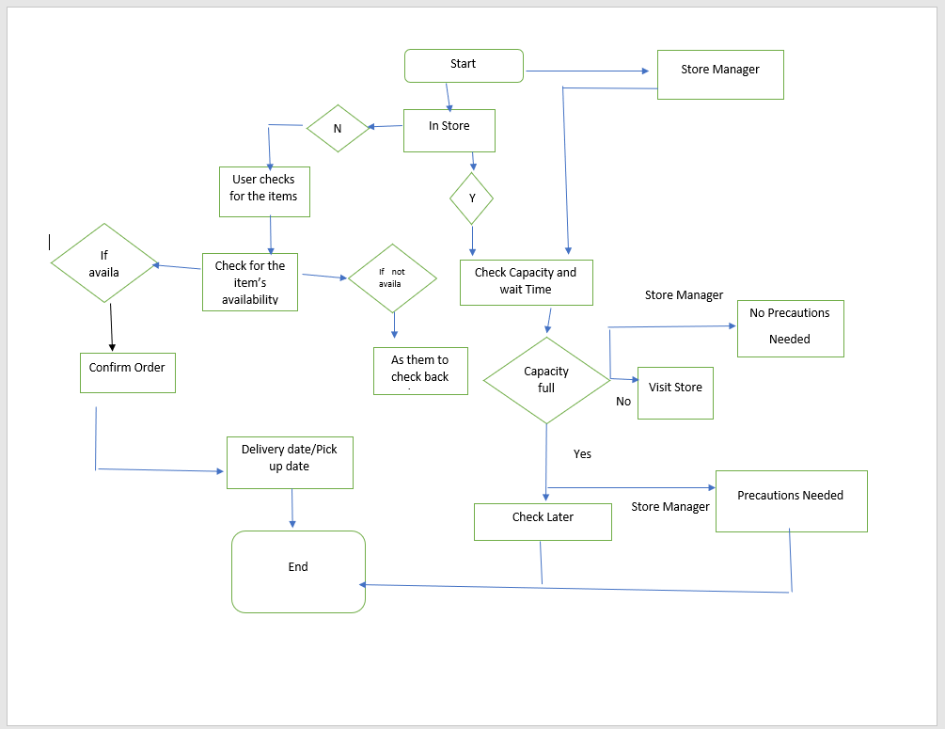

**E. Project Organization**

In the chart below we have broken down the Workflow.

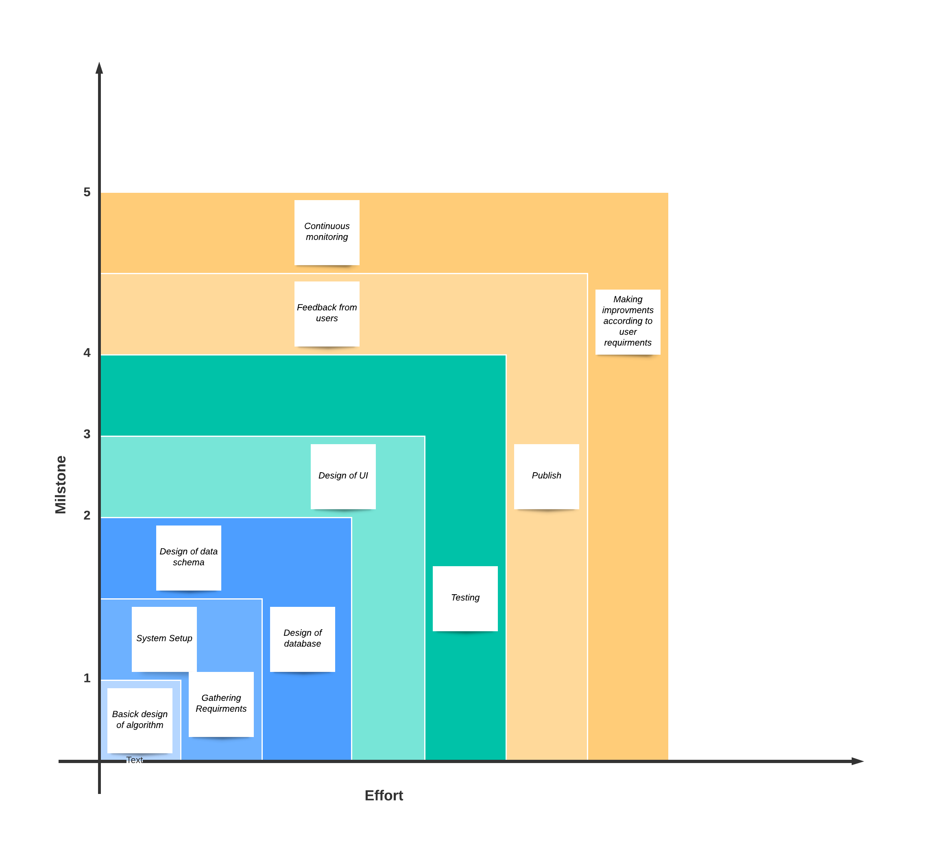

The Gantt Chart shows the timeline of each task finishing with Final Task 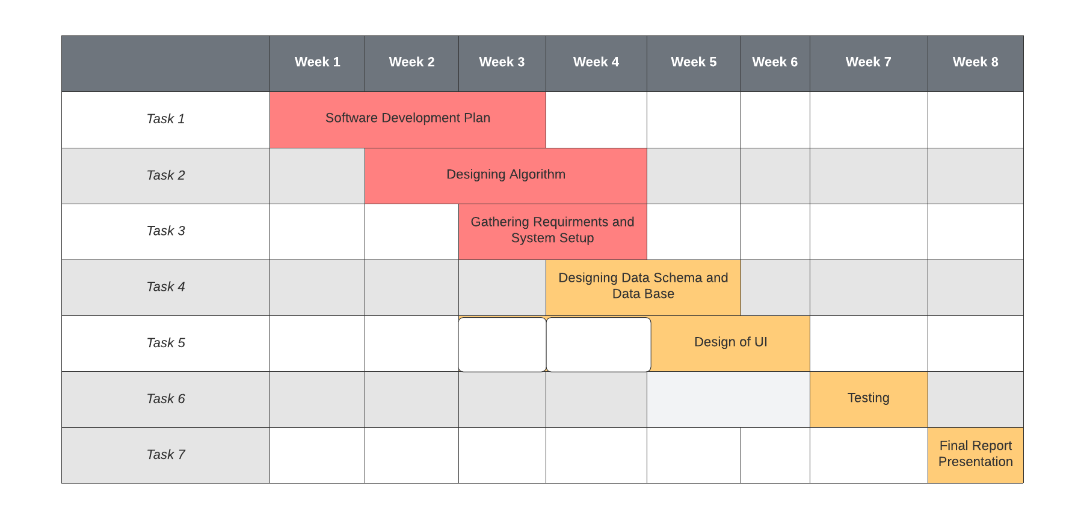

**F. Validation Plan**

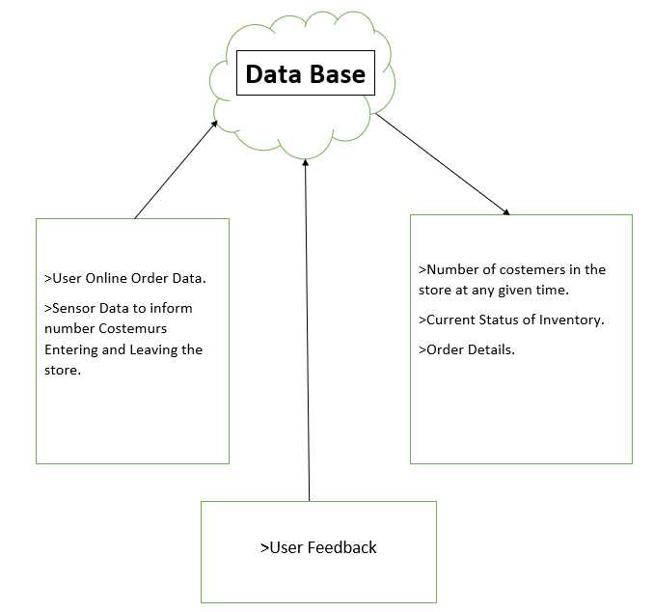

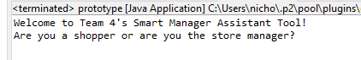

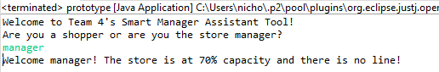

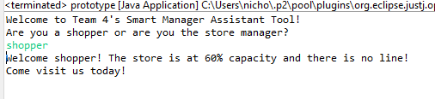

**G. Configuration/Version Control**

In order to create a product that can be adequately updated by all members of the team, we will be utilizing GitHub. For future stages of the projects, individual group members will push their commits to the central repository, located at the URL: <https://github.com/BryanMiletta/CS790-Team-4>

As with many other software development tools employing version control, one of the central features of GitHub is that it retains prior versions of the project, thus allowing us to see who has contributed what work to the project. Additionally, GitHub will allow us to show progress at each stage of the project and allow us to present our work anywhere in the world with internet access.

**H. Tools**

For our project, members of our group will be using Visual Studio 2022 for code development and employing the Java programming language. At this point in the process however, we are still revising what tools & outside libraries we will likely employ to deliver a project that meets the project requirements laid out above. For communication and planning, we have been using Discord and Gnatt to communicate and organize the project respectively.